SAVEETHA SCHOOL OF ENGINEERING
SAVEETHA INSTITUTE OF MEDICAL AND TECHNICAL SCIENCES
COMPUTER SCIENCE AND ENGINEERING PROGRAMME
CSA04 – OPERATING SYSTEMS
Name: DHARANI KARTHICK
Reg no: 192521082

LIST OF PROGRAMS
13. Construct a C program for implementation the various memory allocation strategies.
/* Memory allocation strategies: First, Best, Worst and Next Fit */
#include <stdio.h>
#include <string.h>

#define MAX 20

static void allocate(const char *name, int type, int nb, const int block[],
int np, const int proc[]) {
int rem[MAX]; /* free space left in each block */
int alloc[MAX]; /* block index given to each process (-1 = none) */
int last = 0; /* where Next Fit resumes searching */

memcpy(rem, block, nb * sizeof(int));

for (int i = 0; i < np; i++) {
int idx = -1;

if (type == 3) { /* NEXT FIT */
for (int k = 0; k < nb; k++) {
int j = (last + k) % nb;
if (rem[j] >= proc[i]) { idx = j; last = j; break; }
}
} else {
for (int j = 0; j < nb; j++) {
if (rem[j] < proc[i]) continue;
if (type == 0) { idx = j; break; } /* FIRST FIT: first block that fits */
if (type == 1 && (idx == -1 || rem[j] < rem[idx])) idx = j; /* BEST FIT: smallest that fits */
if (type == 2 && (idx == -1 || rem[j] > rem[idx])) idx = j; /* WORST FIT: largest block */
}
}

alloc[i] = idx;
if (idx != -1) rem[idx] -= proc[i];
}

printf("\n--- %s ---\n", name);
printf("%-9s %-6s %s\n", "Process", "Size", "Block");
for (int i = 0; i < np; i++) {
if (alloc[i] != -1)
printf("P%-8d %-6d B%d\n", i + 1, proc[i], alloc[i] + 1);
else
printf("P%-8d %-6d Not allocated\n", i + 1, proc[i]);
}

int total = 0;
printf("Free space left: ");
for (int j = 0; j < nb; j++) {
printf("B%d=%d ", j + 1, rem[j]);
total += rem[j];
}
printf(" (total %d)\n", total);
}

int main(void) {
setvbuf(stdout, NULL, _IONBF, 0);

int nb, np, block[MAX], proc[MAX];

printf("Enter number of memory blocks: ");
if (scanf("%d", &nb) != 1 || nb < 1 || nb > MAX) return 1;
for (int i = 0; i < nb; i++) {
printf(" Size of block %d: ", i + 1);
scanf("%d", &block[i]);
}

printf("Enter number of processes: ");
if (scanf("%d", &np) != 1 || np < 1 || np > MAX) return 1;
for (int i = 0; i < np; i++) {
printf(" Size of process %d: ", i + 1);
scanf("%d", &proc[i]);
}

allocate("FIRST FIT", 0, nb, block, np, proc);
allocate("BEST FIT", 1, nb, block, np, proc);
allocate("WORST FIT", 2, nb, block, np, proc);
allocate("NEXT FIT", 3, nb, block, np, proc);
return 0;
} 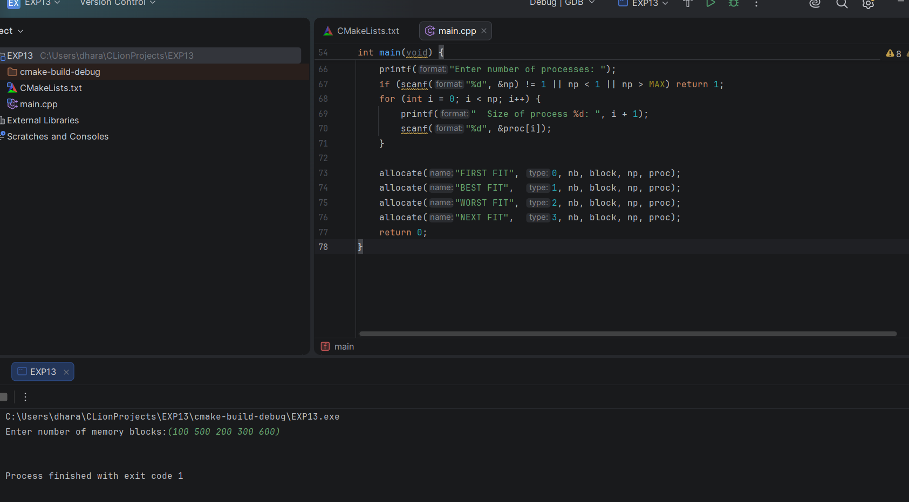
14. Construct a C program to organize the file using single level directory.
/* Single Level Directory */
#include <stdio.h>
#include <string.h>

#define MAX_FILES 50
#define NAME_LEN 30

char files[MAX_FILES][NAME_LEN];
int count = 0;

int find_file(const char *name) {
for (int i = 0; i < count; i++)
if (strcmp(files[i], name) == 0) return i;
return -1;
}

int main(void) {
setvbuf(stdout, NULL, _IONBF, 0);

char dir[NAME_LEN], name[NAME_LEN];
int choice;

printf("Enter name of the directory: ");
scanf("%29s", dir);

while (1) {
printf("\n===== SINGLE LEVEL DIRECTORY [%s] =====\n", dir);
printf("1. Create file\n2. Delete file\n3. Search file\n4. Display files\n5. Exit\n");
printf("Enter your choice: ");
if (scanf("%d", &choice) != 1) break;

switch (choice) {
case 1:
if (count == MAX_FILES) { printf("Directory is full.\n"); break; }
printf("Enter file name: ");
scanf("%29s", name);
if (find_file(name) != -1)
printf("File '%s' already exists. Names must be unique here.\n", name);
else {
strcpy(files[count++], name);
printf("File '%s' created.\n", name);
}
break;

case 2:
printf("Enter file name to delete: ");
scanf("%29s", name);
{
int pos = find_file(name);
if (pos == -1) printf("File '%s' not found.\n", name);
else {
for (int i = pos; i < count - 1; i++)
strcpy(files[i], files[i + 1]); /* close the gap */
count--;
printf("File '%s' deleted.\n", name);
}
}
break;

case 3:
printf("Enter file name to search: ");
scanf("%29s", name);
{
int pos = find_file(name);
if (pos == -1) printf("File '%s' not found.\n", name);
else printf("File '%s' found at position %d in directory '%s'.\n",
name, pos + 1, dir);
}
break;

case 4:
if (count == 0) printf("Directory '%s' is empty.\n", dir);
else {
printf("Files in directory '%s':\n", dir);
for (int i = 0; i < count; i++)
printf(" %d. %s\n", i + 1, files[i]);
}
break;

case 5:
return 0;

default:
printf("Invalid choice.\n");
}
}
return 0;
} 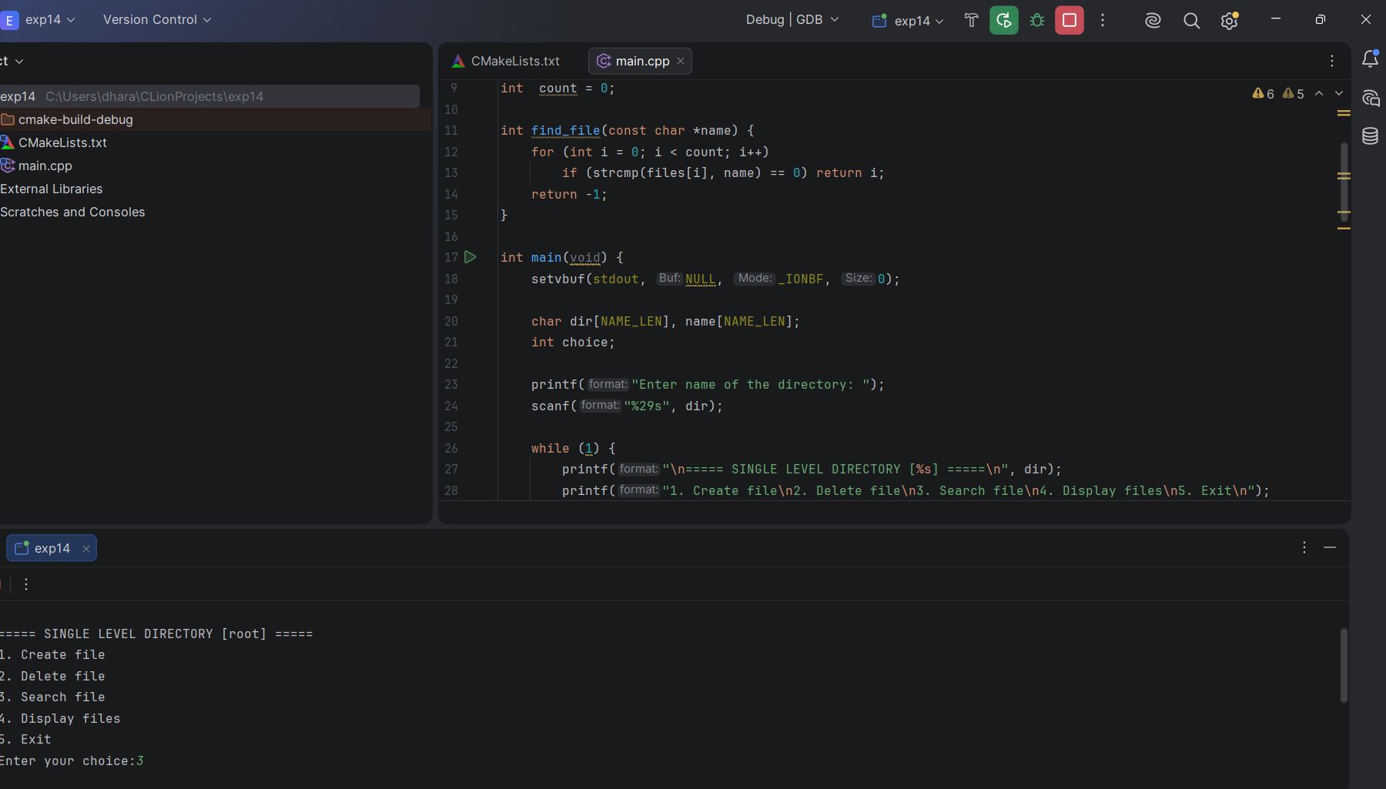
15. Design a C program to organize the file using two level directory structure.
/* Two Level Directory: Master Directory -> User Directories -> Files */
#include <stdio.h>
#include <string.h>

#define MAX_USERS 10
#define MAX_FILES 20
#define NAME_LEN 30

typedef struct {
char name[NAME_LEN]; /* user directory name */
char files[MAX_FILES][NAME_LEN]; /* files of this user */
int fcount;
} UserDir;

UserDir users[MAX_USERS];
int ucount = 0;

int find_user(const char *name) {
for (int i = 0; i < ucount; i++)
if (strcmp(users[i].name, name) == 0) return i;
return -1;
}

int find_file(const UserDir *u, const char *name) {
for (int i = 0; i < u->fcount; i++)
if (strcmp(u->files[i], name) == 0) return i;
return -1;
}

int main(void) {
setvbuf(stdout, NULL, _IONBF, 0);

char uname[NAME_LEN], fname[NAME_LEN];
int choice;

while (1) {
printf("\n===== TWO LEVEL DIRECTORY =====\n");
printf("1. Create user directory\n2. Create file\n3. Delete file\n");
printf("4. Search file\n5. Display all\n6. Exit\n");
printf("Enter your choice: ");
if (scanf("%d", &choice) != 1) break;

switch (choice) {
case 1:
if (ucount == MAX_USERS) { printf("Master directory is full.\n"); break; }
printf("Enter user directory name: ");
scanf("%29s", uname);
if (find_user(uname) != -1)
printf("User directory '%s' already exists.\n", uname);
else {
strcpy(users[ucount].name, uname);
users[ucount].fcount = 0;
ucount++;
printf("User directory '%s' created.\n", uname);
}
break;

case 2:
printf("Enter user directory name: ");
scanf("%29s", uname);
{
int u = find_user(uname);
if (u == -1) { printf("User directory '%s' not found.\n", uname); break; }
if (users[u].fcount == MAX_FILES) { printf("User directory is full.\n"); break; }
printf("Enter file name: ");
scanf("%29s", fname);
if (find_file(&users[u], fname) != -1)
printf("File '%s' already exists in '%s'.\n", fname, uname);
else {
strcpy(users[u].files[users[u].fcount++], fname);
printf("File '%s' created in '%s'.\n", fname, uname);
}
}
break;

case 3:
printf("Enter user directory name: ");
scanf("%29s", uname);
{
int u = find_user(uname);
if (u == -1) { printf("User directory '%s' not found.\n", uname); break; }
printf("Enter file name to delete: ");
scanf("%29s", fname);
int pos = find_file(&users[u], fname);
if (pos == -1) printf("File '%s' not found in '%s'.\n", fname, uname);
else {
for (int i = pos; i < users[u].fcount - 1; i++)
strcpy(users[u].files[i], users[u].files[i + 1]);
users[u].fcount--;
printf("File '%s' deleted from '%s'.\n", fname, uname);
}
}
break;

case 4:
printf("Enter user directory name: ");
scanf("%29s", uname);
{
int u = find_user(uname);
if (u == -1) { printf("User directory '%s' not found.\n", uname); break; }
printf("Enter file name to search: ");
scanf("%29s", fname);
if (find_file(&users[u], fname) == -1)
printf("File '%s' not found in '%s'.\n", fname, uname);
else
printf("File '%s' found in '%s'.\n", fname, uname);
}
break;

case 5:
if (ucount == 0) { printf("Master directory is empty.\n"); break; }
printf("\nMaster Directory\n");
for (int i = 0; i < ucount; i++) {
printf(" |-- %s/\n", users[i].name);
if (users[i].fcount == 0) printf(" | (empty)\n");
for (int j = 0; j < users[i].fcount; j++)
printf(" | |-- %s\n", users[i].files[j]);
}
break;

case 6:
return 0;

default:
printf("Invalid choice.\n");
}
}
return 0;
} 